**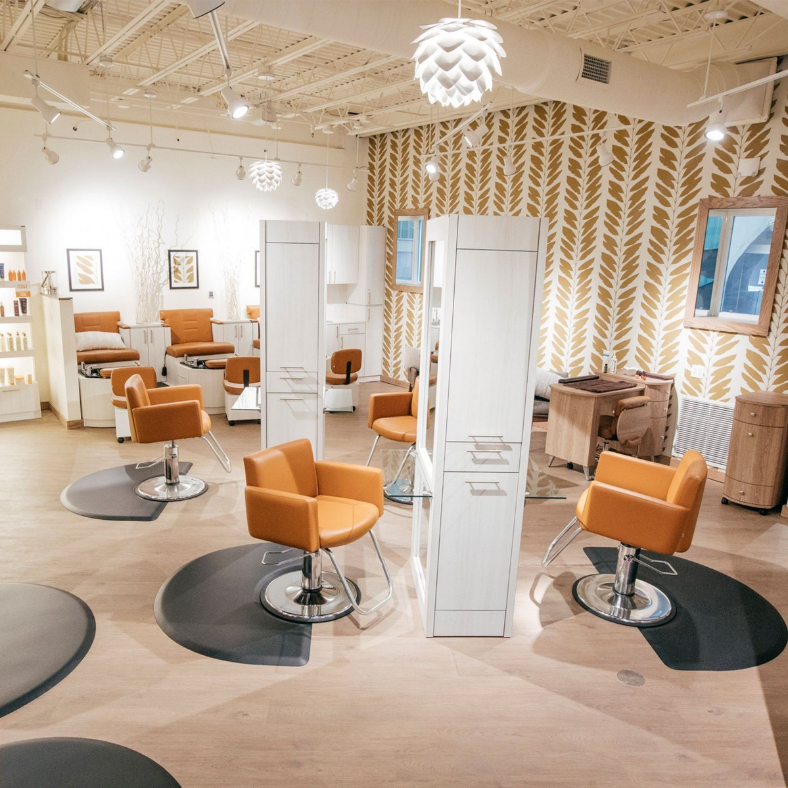*Ayesha Beauty creation***

**ICG GROUP 5 ASSIGNMENT**

**221097988 WILIKO KATSHINYENGA JUNIAS (Group2)**

**217080499 HELAO HANGULA (Group 10)**

**219155453 UETUSUVERA KUHANGA (Group 4)**

**221064281 Mutago !Gaoseb (Group 6)**

**Part A**

***MODULES***

* Supplier
  + - Discherm
    - Pick n Pay
* Product
  + - Hair food
    - Leave in conditioners
    - Hair gel
    - Shampoo
* Employee
* Service
* Finance
* Clients

**Pseudocode For the modularization of Ayesha Beauty creation**

*Begin*

*If login is successful*

*Display* ***main menu***

*If chooses* ***Products***

*Display (view, add and remove products)*

*If selects view process*

*Display (detail products)*

*Else*

*Update products*

*End if*

*Else*

*If chooses* ***suppliers***

*Display (view, add supplier, remove supplier and order products)*

*If selects view process*

*Display detail supplier*

*Else*

*Update supplier*

*Else*

*If chooses* ***Clients***

*Display (view client, add client and remove client)*

*If selects view process*

*Display detail client*

*Else*

*Update Clients*

*Else*

*If chooses* ***Finances***

*Display (view financial records)*

*If selects view process*

*Display finances*

*Else*

*if chooses* ***Driver*** *Display (View Customer)  
 end if  
 Else*

*if chooses* ***Report*** *Display(View Customer)  
 end if  
 else* ***Login Again*** *endif*

*End*

**Flowchart**

Log in

Denied

Authentication

Detail products

Granted

Update products

View process

View, add, remove products

Main menu

Detail supplier

View, add new supplier, remove supplier, order product

Products

View process

suppliers

Update supplier

Detail clients

View process

View client, add client, remove client

clients

View financial record

Finances

Update clients

View process

View client

Store

Detail finances

View client

Report

*Functions under the* ***Supplier*** *module:*

* Ordering stock
* Add Supplier
* Remove Supplier

**Step 1:** Supplier can receive the orders from the business according to the customers’ requests.

**Step 2:** To check if Supplier have information about the stock

**Step 3:** check if the stock needed by the customer is available in stock, if yes a payment should be done and an invoice should be created.

**Step 4:** if stock is not available the supplier should be informed.

***Pseudocode***

*Ordering stock*

Start

Display = log in

Display amount of stock available

If stock runs low than prompt = Reorder new item

Else

If stock is available than prompt = create invoice

Print invoice

End if

End if

End

***Flowchart***

No

No

Create invoice

Payment

Payment

Yes

If stock available

Received order?

Yes

***Pseudocode***

*Addition Of Suppliers*

Begin

Enter supplier details

If all entered details are correct then

Add supplier

Save record

End if

End

***Flowchart***

Enter supplier details

No

All details entered?

Yes

Details correct?

No

Yes

Add supplier

Save record

***Pseudocode***

*Removal of Suppliers*

Begin

Enter suppliers details

If all entered information is correct then

Remove supplier

End if

End

***Flowchart***

Begin

Enter suppliers’ details

All details entered?

No

Yes

Details correct?

No

Yes

Remove supplier

End

*Functions under the* ***Finance*** *module*

* *Payments*
* *Generate receipt*

***Step1:*** *Enter all financial records*

***Step2:*** *Save record*

***Step3:*** *Generate Receipt*

***Step4:*** *Print receipt*

***Pseudocode***

*Payments*

Begin

Enter details

If all details are entered then

Enter payment details

If entered payment details are correct then

Save details

End

***Flowchart***

Enter details of money paid

No

All details entered?

Yes

No

Details correct?

Yes

Enter details of money paid

All details entered?

Details correct?

Save record

***Pseudocode***

*Generate receipt*

Begin

Enter payment details

If all details entered are correct then

Print receipts

Save record

End if

End

Generate receipts

Enter payment details

All details entered?

No

Yes

Details correct?

No

Yes

Print receipts

Save record

*Functions under the* ***Clients*** *module*

* Add Client
* Remove/Delete Client
* Search Client

***Step 1:*** *Enter details for the new client in order to register them in Ayesha Beauty Creation system.*

***Step 2:*** *Save the record.*

***Step 3:*** *Delete any record belonging to a client that has left Ayesha Beauty Creation for any particular reason such as returning a product. Once a client has returned a product, it is irrelevant for their details to be still saved.*

***Step 4:*** *Search for any desired clients file*

***Pseudocode***

*Add Client*

Begin

Enter clients details

If all entered details are correct then

Add client

Save record

End if

End

***Flowchart***

Enter clients’ details

No

All details entered?

Yes

Details correct?

No

Yes

Add client

Save record

***Pseudocode***

*Remove Client*

Begin

Enter clients details

If all entered details are correct then

Remove client

End if

End

***Flowchart***

Begin

Enter clients’ details

All details entered?

No

Yes

Details correct?

No

Yes

Remove clients

End

***Pseudocode***

*Search Client*

Begin

Enter client details

If all client details entered are correct then

find client

save record

End if

End

***Flowchart***

Enter client details

All details entered?

No

Yes

Details correct?

No

Yes

Save record

Find client

*Functions under the* ***Services*** *module*

* *Add service*
* *Remove service*

***Step 1:*** *Services is basically the clients buying products from Ayesha Beauty Creations and this has to be recorded as a service rendered.*

***Step 2:*** *The service offered has to be recorded by adding a service record.*

***Step 3:*** *Once the customer is no longer having any connections with Ayesha Beauty Creations, the service record for that particular client is removed.*

***Pseudocode***

*Add service*

Begin

Enter service details

If all service details entered are correct then

Add service

Save record

End if

End

***Flowchart***

Enter service details

No

All details entered?

Yes

Details correct?

No

Yes

Add service

Save record

***Pseudocode***

*Remove service*

Begin

Enter service details

If all service details entered are correct then

remove service

End if

End

***Flowchart***

Begin

Enter service details

All details entered?

No

Yes

Details correct?

No

Yes

Remove service

End

*Functions under the* ***Products*** *module*

* *Add Product*
* *Remove Product*
* *Search Product*

***Step 1:*** *Products have to be ordered from the suppliers, so when received by Ayesha by, they have to record that product as new, thus adding it.*

***Step 2:*** *Products can also be deleted because they have been bought and are currently unavailable*

***Step 3:*** *Products can also be searched for.*

***Pseudocode***

*Add Product*

Begin

Enter product details

If all product details entered are correct then

Add product

Save record

End if

End

***Flowchart***

Adding a Product

Enter product details

All details entered?

No

Yes

Details correct?

No

Yes

Save record

***Pseudocode***

*Remove Product*

Begin

Enter Product details

If all product details entered are correct then

remove product

End if

End

Flowchart

Enter product details

All details entered?

No

Yes

Details correct?

No

Yes

Delete product

Save record

***Pseudocode***

*Search For product*

Begin

Enter Product details

If all product details entered are correct then

find product

save record

End if

End

*Flowchart*

Search any product

Enter product details

All details entered?

No

Yes

Details correct?

No

Yes

Save record

Find product